STEP1:ENTER THE DIRECTORY CONTAINING KAFKA
We have to enter into folder containing kafka and start executing kafka commands after start ing ZOO KEEPER AND KAFKA SERVER

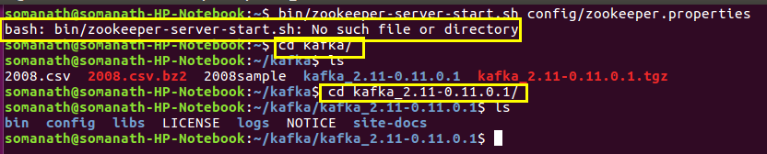

STEP 2: START ZOO KEEPER
use the below comand to start zoo keeper
bin/zookeeper-server-start.sh config/zookeeper.properties

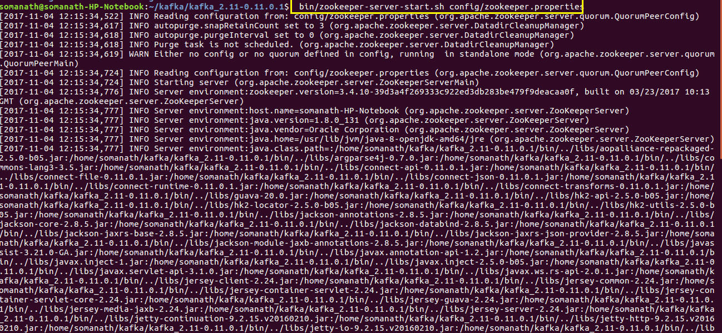
STEP3 : START KAFKA SERVER
Use the below comand to start KAFKA SERVER

bin/kafka-server-start.sh config/server.properties

ONCE WE STARTED THE SERVER WE HAVE TO start producer which will suuply messages based on a specific topic

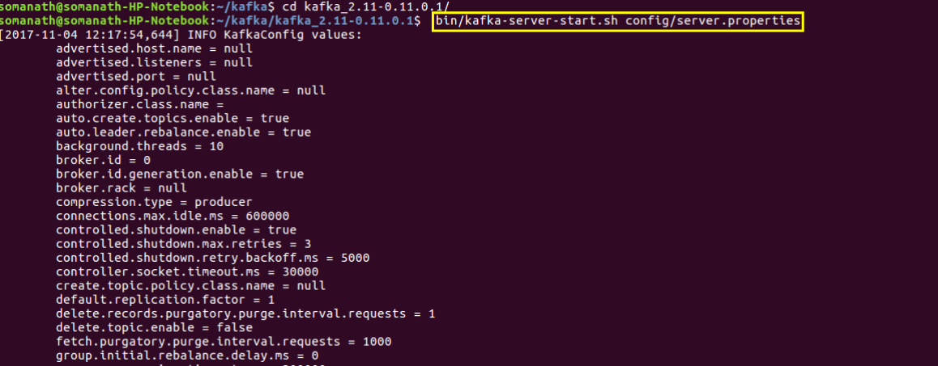
STEP 4:Start Producer

Use the following command to start producer
bin/kafka-console-producer.sh --broker-list localhost:9092 --topic OTP
enter the input
as hai ,hello

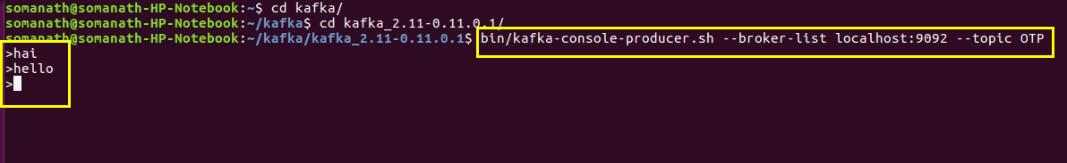
Step5 :Use consumer to get the data
start teh consumer with same dfrom same localhost and same topic to receive the data
bin/kafka-console-consumer.sh --bootstrap-server localhost:9092 --topic OTP

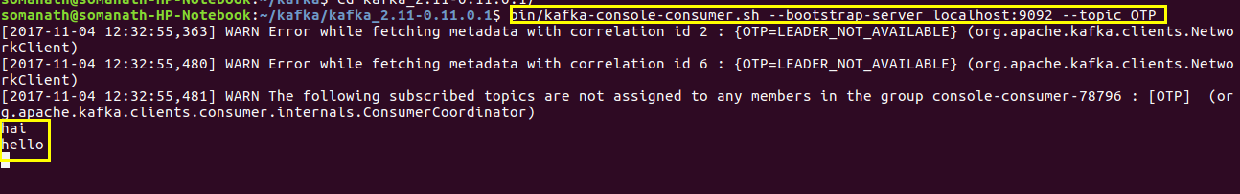
we will see the hai hello messages received as highlighted

IN order to read data from a file into a producer we will insert the sample file
Using the following command
cat ~/kafka/2008sample|bin/kafka-console-producer.sh --broker-list localhost:9092 --topic OTP
we will see that in consumer the following data will be received
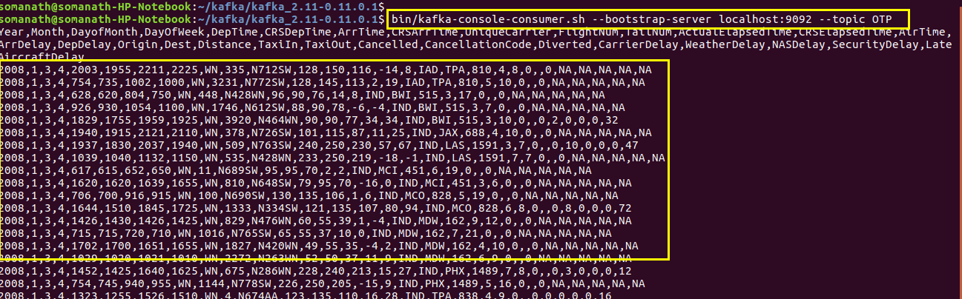
Now we can use streaming library of pyspark and receive the message as A RDD usin the following code
spark-submit --packages org.apache.spark:spark-streaming-kafka-0-8_2.11:2.1.0 'kafka_stream.py' localhost:2181 PlaneDate

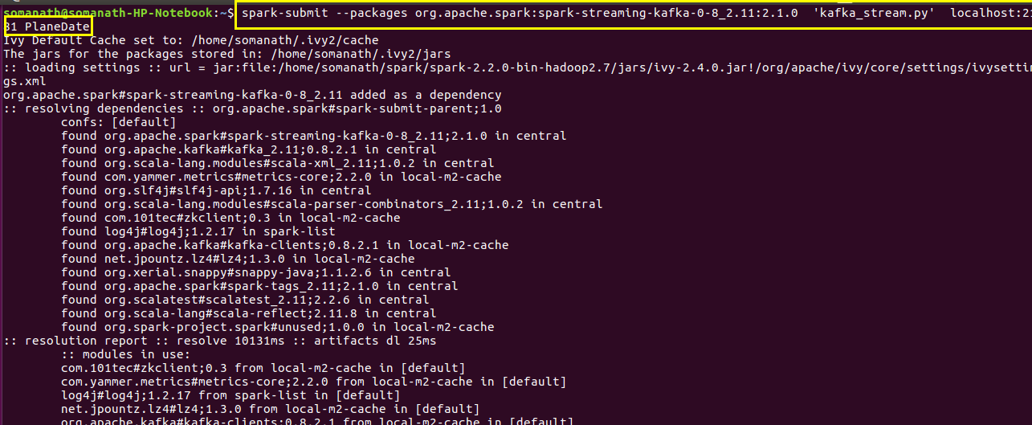

kafka_stream.py code

import sys
from pyspark.sql import SQLContext
from pyspark import SparkContext
from pyspark.streaming import StreamingContext
from pyspark.streaming.kafka import KafkaUtils
from pyspark.sql.types import *
if __name__ == "__main__":
if len(sys.argv) != 3:
# print("Usage: kafka_wordcount.py <zk> <topic>", file=sys.stderr)
exit(-1)
sc = SparkContext(appName="
sqlContext = SQLContext(sc)
ssc = StreamingContext(sc, 30)
zkQuorum, topic = sys.argv[1:]
kvs = KafkaUtils.createStream(ssc, zkQuorum, "spark-streaming-consumer", {topic: 1})
#type(kvs)
#kvs.saveAsTextFiles("spark_
parsed1 = kvs.map(lambda (k, v): v).saveAsTextFiles("spark_
#header = parsed.first()
#data = parsed.filter(lambda row : row != header).toDF(header)
#parsed.toDF()

Output :

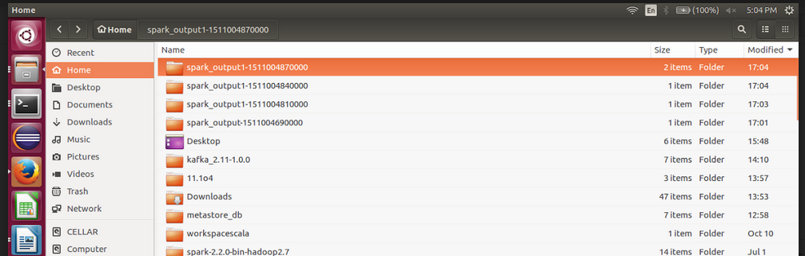

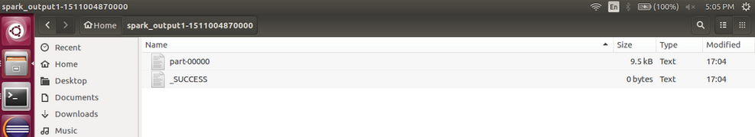

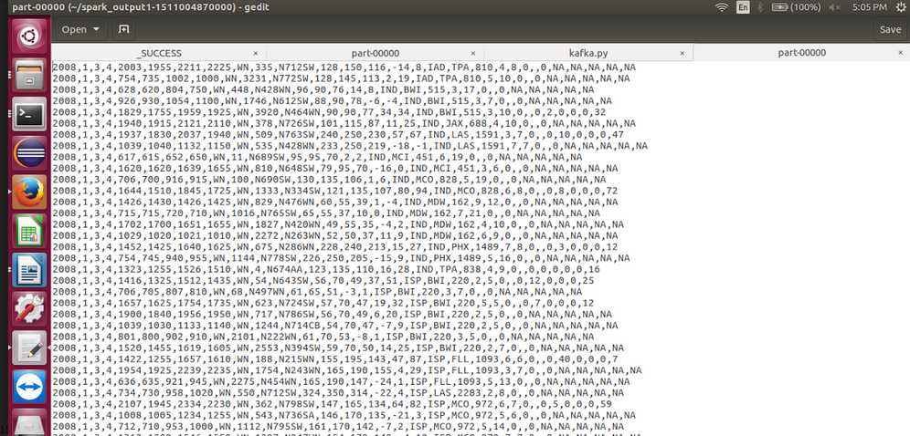

step2:Moving file into hdfs

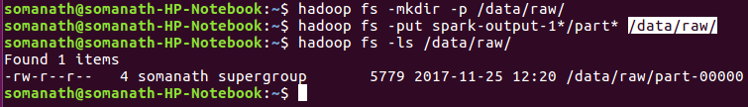

STEP 3: adding Unix timestamp and UUID using pig script
run the below pig script to add UUID and timestamp and store as avrofile

a = load '/data/raw/part-00000' using PigStorage(',') as (Year:chararray,Month:chararray,DayofMonth:chararray,DayOfWeek:chararray,
DepTime:chararray,CRSDepTime:chararray,ArrTime:chararray,CRSArrTime:chararray,UniqueCarrier:chararray,lightNum:chararray,TailNum:chararray,
ActualElapsedTime:chararray,CRSElapsedTime:chararray,AirTime:chararray,ArrDelay:chararray,DepDelay:chararray,Origin:chararray,
Dest:chararray,Distance:chararray,TaxiIn:chararray,TaxiOut:chararray,Cancelled:chararray,CancellationCode:chararray,
Diverted:chararray,CarrierDelay:chararray,WeatherDelay:chararray,NASDelay:chararray,SecurityDelay:chararray,LateAircraftDelay:chararray);

b = filter a by Year!='Year';

c = foreach b {
currTime = CurrentTime();
year = (chararray)GetYear(currTime);
month = (chararray)GetMonth(currTime);
day = (chararray)GetDay(currTime);
generate *,UniqueID() as UUID,CONCAT(CONCAT(CONCAT(year, '-'), CONCAT(month, '-')),day) as unixtimeStamp;
}

STORE c into '/data/decomposed/' using AvroStorage ();

Step4 :Cleaning data using spark

Use below code for removing duplicated

val df = spark.read.format("com.databricks.spark.avro").load("hdfs://localhost:9000/data/decomposed/part-m-00000.avro");
val df1=df.dropDuplicates();
df1.write.parquet("hdfs://localhost:9000/data/modelled/cleansed");

Step5:Creating hive
Create external table in the above location and start querying as shown below
Create external table air_det (Year string,Month string,DayofMonth string,DayOfWeek string,
DepTime string,CRSDepTime string,ArrTime string,CRSArrTime string,UniqueCarrier string,lightNum string,TailNum string,
ActualElapsedTime string,CRSElapsedTime string,AirTime string,ArrDelay string,DepDelay string,Origin string,
Dest string,Distance string,TaxiIn string,TaxiOut string,Cancelled string,CancellationCode string,
Diverted string,CarrierDelay string,WeatherDelay string,NASDelay string,SecurityDelay string,LateAircraftDelay string,UUID string,unixtimeStamp string) stored as Parquet
LOCATION "hdfs://localhost:9000/data/modelled/cleansed"
;

select Year,Month,DayofMonth from air_det where DepDelay in (select min(DepDelay) from air_det);

